 

# GMR INSTITUTE OF TECHNOLOGY, RAJAM

(An Autonomous Institution, Accredited by NBA of AICTE, NAAC of UGC & an ISO 9001:2015 Institution)

# STEPCONE 2023

EVENT WISE BUDGET LIST

|  |  |  |  |  |  |  |  |  |  |  |
| --- | --- | --- | --- | --- | --- | --- | --- | --- | --- | --- |
| **Department of:** Computer Science and Engineering | | | | | | |  |  |  |  |
| **Faculty SPOC Nominated:** Dr. K. Srividya | | | | | | | **Mobile:** 9493470658 | |  |  |
| **S.NO** | **TENTATIVE EVENT** | **REGN. FEE** | **EXPECTED REGISTRATIONS** | **AMOUNT FROM REGISTRATIONS** | **OTHER COSTS** | | **PRIZE MONEY** | | | **BUDGET EXPECTED** |
| **ITEMS** | **PRICE** | **1ST** | **2ND** | **3RD** |
| 1 | Webathon | 1000/- | 50 | 50,000/- | Snacks | 8000/- | 20,000/- | 13,000/- | 9000/- | 0 |
| 2 | Code Mania | 500/- | 100 | 50,000/- | Coins  Refreshments & goodies | 10000/- 17500/- | 10,000/- | 75,000/- | 5000/- | 0 |
| 3 | Model UN | 1000/- | 50 | 50,000/- | Event Arrangements  Refreshments | 11,000/-  10,000/- | 15,000/- | 9,000/- | 5,000/- | 0 |
| 4 | League of legends | 400/- | 100 | 40,000/- | Banners, photo lobby | 20000/- | 6000/-, 6000/- | 4000/-, 4000/- | NA | 0 |
| 5 | Codigo | 300/- | 100 | 30,000/- | Snacks and Rough Sheets | 5000/- | 15,000/- | 10,000/- | NA | 0 |

**Tentative Event:** Web-a-thon

**Budget Proposed:** Rs. 50,000/-

**Target Audience:** CSE AI-ML, AI-DS & IT

**Event Coordinators:** K. Charan, S. Jyothi Lavanya

**Description:** Participants have to create a web interface based on the problem statement that would be given on the spot. The participants are allowed to use various resources like google, YouTube, etc. It is the participants’ choice to use whatever technology they wish. The team should complete their interface in the given 12 hours. There will be a total of 3evaluations.

**Tentative Event:** CODE MANIA

**Budget Proposed:** Rs. 32,500/-

**Target Audience:** CSE, IT, ECE

**Event Coordinator**: Ch.Venkata Sai kiran, S.Sumalatha, K.Surya Prakash, L. komali

**Description:** Round 1: CODE AUCTION

Code Auction is a team-based event, where each team gets credits of 500 CSI Coins. These coins can be used to buy Problem Statements during the auction of a problem statement. Each problem statement has some base points based on the difficulty of the statement. After a team buys a problem statement, if the team solves the code, then the team’s points will be increased by the base prize of the statement. A team cannot buy another code if they didn’t solve at least 40% of the code. After all the codes are sold, the team with highest points is declared as winner.

Round 2: LOGIC MANIA: Three Problem Statements will be given to participants; these problem statements only contain Inputs and outputs rather than the description of the problem. Participants must write a code which satisfies all the test cases for the given input and output.

**Tentative Event:** MODEL UN

**Budget Proposed:** Rs. 32,500/-

**Target Audience:** All branches

**Event coordinator:** G. Likash, D. Shriya

**Description:** This event is a mock representation of the working UNO (United Nations

Organization). Each team will represent different countries and each team had to choose one country to represent in the event from the provided list of countries during registration. The sectors of different countries need to be discussed in the event: Environment, Women Safety, Education, Human Rights, Maintenance of international peace and security, Heritage, and culture.

**Tentative Event:** League of Legends

**Budget Proposed:** Rs. 40,000/-

**Target Audience:** CSE, ECE, IT, CHEM, MECH, CIV, EEE.

**Event coordinators:** K. Sai Kiran, M. Hemant

**Description:** This Esports events comprise many games, both popular and under the radar, in numerous genres. We divided this event into 3 Sub-events,

1. - Mobile based (Main Stream events, which need a cash prize)

Here we conduct Online PvP Matches among the players and transparently winners are declared. We are Planning 2 PvP mode

games

1. 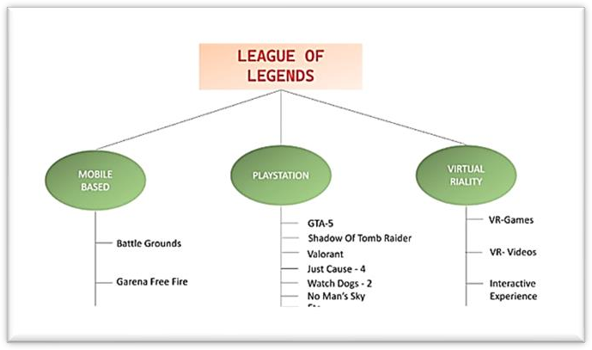- PlayStation (PC) (Revenue generating events, no need to have prize pool) 3 - Virtual Reality (Revenue generating events, no need to have prize pool)

**Tentative Event:** Codigo

**Budget Proposed:** Rs. 30,000/-

**Target Audience:** All branches

**Event coordinators:** D. Bhargavi, V. Bhavani Prasad

**Description:** There will be 3 rounds in the event- Pattern Printing, Unlock Me and Lock Out. The first round is a Pattern Printing round. In this there will be 4-5 Questions on printing patterns. In the second Round (Unlock Me), We will provide some code snippets. The participants should predict the output. In the final round Each group will be given a set of 6 questions and a timestamp of 30 minutes.